

Nokia 1203

Description
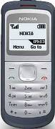
Nokia 1203 is a durable and user-friendly handset that helps you stay in touch with your friends and family.

STORE PRICE: Rs 1,144 /-
ONLINE PRICE: Rs 1,048 /-

Brand : Nokia
Model Name : 1203
Released Year : 2009
Phone Memory : 4MB internal memory
External Memory : No
Colors : Silver grey
Form : Bar
Dimensions : 105.3 x 45 x 13.1 mm
Weight : 78g

